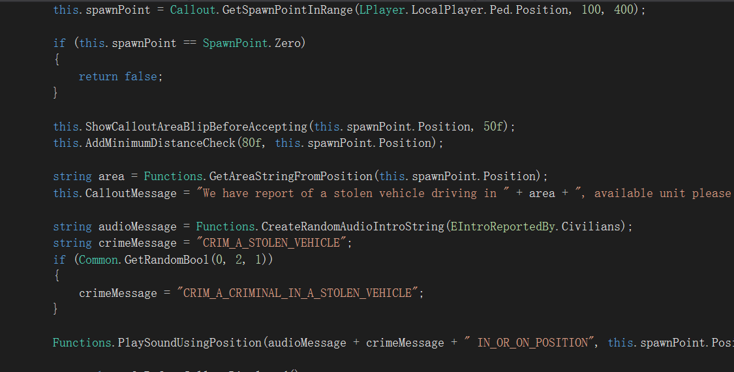

Part from code

Hot Call-outs Manual

FOR END USERS

*Forgot the bad styled document*

## Introduction

A long time ago I was thinking developing a new modification but not go so well. That time I started the “Lightweight” adaption of the mod.

But it ends going messy. So, I was thinking “*how about develop a new plugin*” without using API Example.

This callout plugin is open source. You can download sources, or contribute, at:

<http://github.com/RelaperCrystal/HotCallouts>

This plugin has currently 6 callouts implemented and 4 were available in game.

I may implement a callout which is exclusive to The Ballad of Gay Tony DLC.

## Installing

First, open the self-extract package. Select the LCPDFR folder in your Grand Theft Auto IV folder. (*Make sure LCPDFR 1.1 is installed. Some guy thinking 1.0D can work but this is compiled on 1.1 so it must run on 1.1)*

Whatever thing you used to launch the game, but Complete Edition is not supported.

This is not self-contained. It will not 100% work with other mods and plugins, but in fact, my test platform runs Hot Call-outs along with Wouters Call-outs and Call-outs+, and it was running Police Helper.

## Configurating

Hot Call-outs uses default .NET configurating. It will run on default configuration, since the plugin has no key bindings.

## Playing

This plugin has 4 playable and 6 implemented callouts.

**Callouts**

**Stolen Vehicle *(not playable)***

Someone steals a car and driving on the street. Go apprehend the driver.

**Dangerous Driver**

A dangerous driver has been sighted on the street. Go find the driver, pull him over, and apprehend him.

**Firearm Attack on An Officer (Situation 1)**

Someone shoots at an officer, and attacked officer calls for backup. Go neutralize or apprehend the suspect.

**Suspect took aim at an officer with firearm (Situation 2)**

Someone taking aim at an officer with his firearm. Officer holds this suspect and calls for help.

Apprehend or neutralize this suspect.

**Suspect holding gun to an officer, and refuse command (Situation 3)**

Someone holds a gun when standing face-to-face to an officer and refuse to comply order. Go apprehend or neutralize this suspect.

**Random Shooting**

An armed suspect shooting randomly. Go apprehend to neutralize this suspect.

**Prison Break *(not playable)***

LCPD Prisoner transport truck has been hijacked! Two suspects hijacked a prisoner transport truck, which carries a prisoner. Remember, the prisoner will always comply order, but two hijackers not. Go apprehend or neutralize hijackers, and apprehend the prisoner. It’s not a pursuit so you can block the truck and order suspect out of the truck.

**Terrorist Attack *(not playable)***

A modified version of Random Shooting which presents a dangerous suspect armed with Carbine Rifle. Take him out, really, because this guy is totally out of his mind out it’s too late to get him in the correction.

**World Events**

**Mugging**

Remember the mugging callout presents in default LCPDFR, right? It is the same logic but it’s happening in front of your face.

**A man with weapon *(not playable)***

Someone totally forgot the gun control codes and hold a gun while walking on the street. Go apprehend him.

**Additional**

**Test Sound Effect Comes with LCPDFR**

You can play sound effect comes with LCPDFR by entering:

*PlayLCPDFRSound <sound name>*

## Footnotes

For developers, see Developer Manual.